earn prac8

- npx create-react-app appname

-npm install web-vitals

-npm istall swr (install it in the your appname folder me)

-copy code from site and paste in app.js(src wale me)

-cd appname

-npm start

paste this code in app.js:

import useSWR from 'swr';

// Import useSWR from swr package

// created function to handle API request

const fetcher = (...args) => fetch(...args).then((res) => res.json());

const App = () => {

const {

data: countries,

error,

isValidating,

} = useSWR('https://restcountries.com/v2/all', fetcher);

// Handles error and loading state

if (error) return <div className='failed'>failed to load</div>;

if (isValidating) return <div className="Loading">Loading...</div>;

return (

<div>

{countries &&

countries.map((country, index) => (

<img key={index} src={country.flags.png} alt='flag' width={100} />

))}

</div>

);

};

export default App;

output:

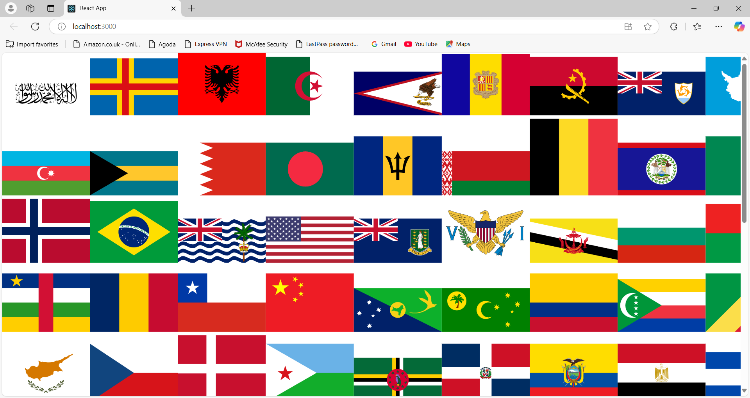

2) for Indian flag:

-the steps for inian flags

1. https://restcountries.com/v2/all (isme sare countries and capital milenge)

2.https://restcountries.com/ (yaha se chose karne ka ki capital and currency then copy the url for capital or currency in the code)

3. below we chose capital i.e. new delhi

4 snipet code:useSWR('https://restcountries.com/v3.1/capital/New Delhi', fetcher);

import useSWR from 'swr';

// Import useSWR from swr package

// created function to handle API request

const fetcher = (...args) => fetch(...args).then((res) => res.json());

const App = () => {

const {

data: countries,

error,

isValidating,

} = useSWR('https://restcountries.com/v3.1/capital/New Delhi', fetcher);

// Handles error and loading state

if (error) return <div className='failed'>failed to load</div>;

if (isValidating) return <div className="Loading">Loading...</div>;

return (

<div>

{countries &&

countries.map((country, index) => (

<img key={index} src={country.flags.png} alt='flag' width={100} />

))}

</div>

);

};

export default App;

output:

